**Lab 5 : PI Motor Controller**

Authors: Benjamin Fields and Miles Alderman

ME 305-03

Dr. Espinoza-Wade

Cal Poly University

Spring 2022

**Lab Overview:**

In this lab we programmed an interrupt service routine to execute the proportion-integral control of a DC motor. The interrupt service routine was designed to work with a prebuilt interface which allowed for keypad based user input and a display to indicate voltages, error, motor effort, and current parameter values. This report outlines our calculations for characterizing the system in both closed and open loop modes of operation, and compares the experimentally measured step response to a theoretical Simulink model.

**Motor parametrization:**

**Tables**

**Table 1.** Open Loop Step Response Characterization and Calculations.

|  |  |  |  |  |  |  |  |  |
| --- | --- | --- | --- | --- | --- | --- | --- | --- |
|  | |  |  |  |  |  |  |  |
| Kp input | Kp Value | Vref | Vact | Vmin | Vmax | Vtau | Settling Time (ms) | Tau (s) |
| 717 | 0.7002 | 200 | 31 | 5.00 | 6.12 | 5.7056 | 44 | 0.011 |
| 300 | 48 | 5.00 | 6.6 | 6.008 | 50 | 0.0125 |
| 400 | 64 | 5.00 | 7.16 | 6.3608 | 44 | 0.011 |
| 500 | 81 | 5.00 | 7.68 | 6.6884 | 50 | 0.0125 |
| 600 | 96 | 5.00 | 8.2 | 7.016 | 50 | 0.0125 |
| 1500 | 1.46484 | 200 | 68 | 5.00 | 7.28 | 6.4364 | 40 | 0.01 |
| 300 | 101 | 5.00 | 8.36 | 7.1168 | 44 | 0.011 |
| 400 | 136 | 5.00 | 9.48 | 7.8224 | 50 | 0.0125 |
| 500 | 145 | 5.00 | 9.76 | 7.9988 | 50 | 0.0125 |
| 600 | 145 | 5.00 | 9.76 | 7.9988 | 50 | 0.0125 |
| 1000 | 0.97656 | 200 | 44 | 5.00 | 6.52 | 5.9576 | 34 | 0.0085 |
| 300 | 67 | 5.00 | 7.28 | 6.4364 | 44 | 0.011 |
| 400 | 90 | 5.00 | 8 | 6.89 | 50 | 0.0125 |
| 500 | 112 | 5.00 | 8.76 | 7.3688 | 46 | 0.0115 |
| 600 | 136 | 5.00 | 9.48 | 7.8224 | 46 | 0.0115 |
|  | Calcs |  |  |  |  |  | Mean Tau | 0.011533 |
|  | Vact/Vref | 0.163 |  |  |  |  |  |  |
|  | K_p | 0.70019531 |  |  |  |  |  |  |
|  | K | 0.23279219 |  |  |  |  |  |  |
|  | K_m | 9.51694915 |  |  |  |  |  |  |
|  | Tau_m | 0.01153333 |  |  |  |  |  |  |

**Table 2.** Closed Loop Step Response Characterization.

|  |  |  |  |  |  |  |  |  |
| --- | --- | --- | --- | --- | --- | --- | --- | --- |
| Kp input | Kp Value | Vref | Vact | Vmin | Vmax | Vtau | Settling Time (ms) | Tau (s) |
| 717 | 0.7002 | 100 | 12 | 5.00 | 5.52 | 5.3276 | 20 | 0.005 |
| 200 | 27 | 5.00 | 5.92 | 5.5796 | 23 | 0.00575 |
| 300 | 41 | 5.00 | 6.44 | 5.9072 | 30 | 0.0075 |
| 400 | 56 | 5.00 | 6.84 | 6.1592 | 30 | 0.0075 |
| 500 | 70 | 5.00 | 7.32 | 6.4616 | 35 | 0.00875 |
| 1500 | 1.46484 | 100 | 24 | 5.00 | 5.92 | 5.5796 | 20 | 0.005 |
| 200 | 50 | 5.00 | 6.72 | 6.0836 | 22 | 0.0055 |
| 300 | 75 | 5.00 | 7.52 | 6.5876 | 25 | 0.00625 |
| 400 | 101 | 5.00 | 8.36 | 7.1168 | 30 | 0.0075 |
| 500 | 127 | 5.00 | 9.16 | 7.6208 | 30 | 0.0075 |
| 1000 | 0.97656 | 100 | 17 | 5.00 | 5.64 | 5.4032 | 20 | 0.005 |
| 200 | 36 | 5.00 | 6.24 | 5.7812 | 22 | 0.0055 |
| 300 | 55 | 5.00 | 6.84 | 6.1592 | 27 | 0.00675 |
| 400 | 74 | 5.00 | 7.44 | 6.5372 | 30 | 0.0075 |
| 500 | 92 | 5.00 | 8.04 | 6.9152 | 30 | 0.0075 |
|  |  |  |  |  |  |  | Mean Tau | 0.006567 |

**Table 3.** Closed Loop nominal and modified calculated values.

|  |  |
| --- | --- |
| Vact/Vref | 0.145 |
| Kp | 0.700 |
| Ki | 0.225 |
| K | 0.2422 |
| Km | 9.9017 |
| Tau_m | 0.0076 |
| Tau_m avg | 0.0096 |
| K avg | 0.2374 |
| wn | 52.737 |
| zeta | 1.0396 |
|  |  |
| Target Parameter Calcs | |
| zeta* | 0.95 |
| wn* | 88.07 |
| Ki* | 0.627 |
| Ki* input | 642.56 |

**Plots:**

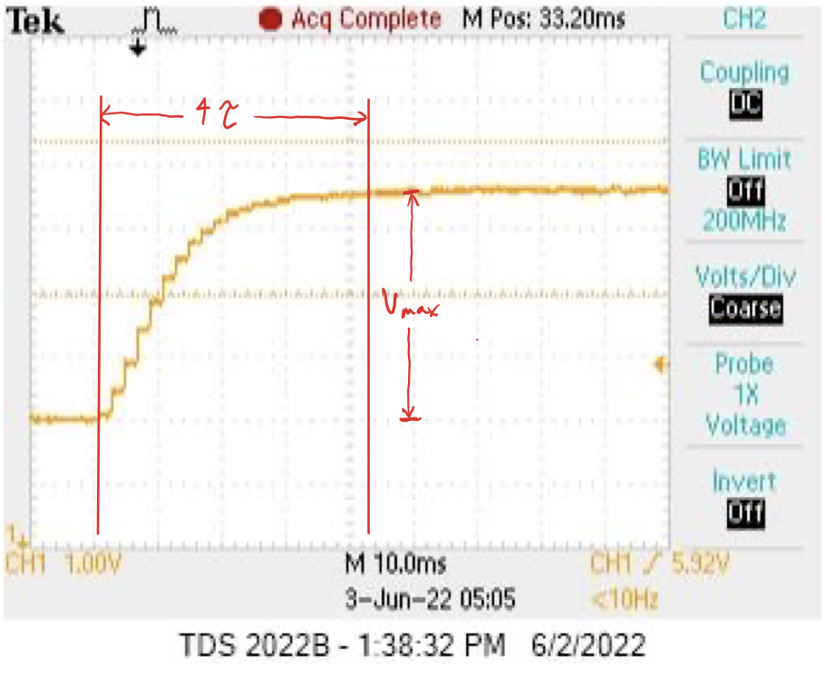

**Figure 1.** Oscilloscope screenshot of parametrization tests showing annotations used for calculations

**Figure 2.** Open loop parametrization curve at K_p = 0.59 and V_ref = 600

**Figure 3.** Closed loop parametrization curve at K_p = 0.59 and V_ref = 600

**Figure 4.** Actual voltage versus reference voltage for open loop step response from 200 to 600 reference voltages. Slope used for calculating Cap K for open loop. Kp = 0.700, Ki = 0.

**Figure 5.** Actual voltage versus reference voltage for closed loop step response from 200 to 600 reference voltages. Slope used for calculating Cap K for closed loop. Kp = 0.700, Ki = 0.

**Calcs**

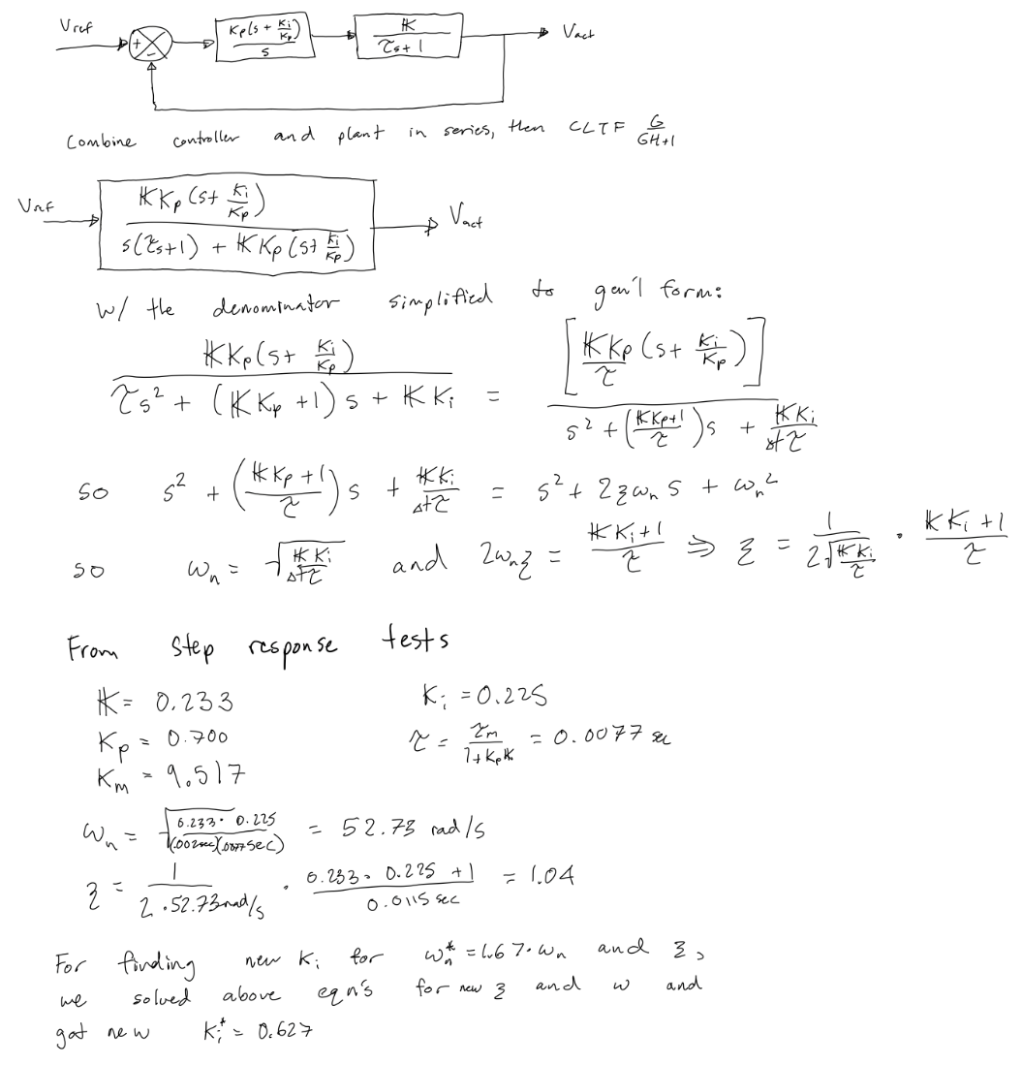

**Figure 6.** Hand calculations for motor parametrization

**Results**

**Table 4.** Key Results

|  |  |
| --- | --- |
| Parametrization | |
| K_motor | 9.9017 |
| Tau_motor*** | 0.0096 |
| Nominal Gains (Kp = 0.7, Ki = 0.225) | |
| w_n | 52.737 |
| zeta | 1.0396 |
| wn* = 1.67 wn. (zeta* = 0.95) | |
| K_p | 0.627 |
| K_i | 642.56 |

*** Tau_motor is an average of open and closed loop parametrization

**Step response plots (actual and simulated for wn*, zeta\***

**Figure 7.** Theoretical vs Experimental Closed Loop Step Response. Zeta* = 0.95, natural frequency* = 1.67*natural frequency.